Suburb Management

A suburb is a residential area or a mixed use area, either existing as part of a city or urban area or as a separate residential community within commuting distance of a city. In most English-speaking regions, suburban areas are defined in contrast to central or inner city areas, but in Australian English and South African English, "suburb" has become largely synonymous with what is called a "neighborhood" in other countries and the term extends to inner city areas. In some areas, such as Australia, China, New Zealand, the United Kingdom, and a few U.S. states, new suburbs are routinely annexed by adjacent cities. In others, such as Arabia, Canada, France, and much of the United States, many suburbs remain separate municipalities or are governed as part of a larger local government area such as a county.

Add Suburb :
This feature facilitates the addition of new suburbs in a specified locality. Once the locality is chosen an option to Add Suburb is automatically displayed.

A search engine has also been provided for searching for a particular suburb by providing the city as an input parameter.
For every new city there is a corresponding Other suburb that is automatically created for that particular city.
We may also edit or make modifications to the various credentials of a suburb.

NOTE :

It must be kept in mind that under Inactive city we cannot have any Active suburb.
A suburb may be declared Inactive only and only when all the localities under the concerened suburb are in Inactive status.

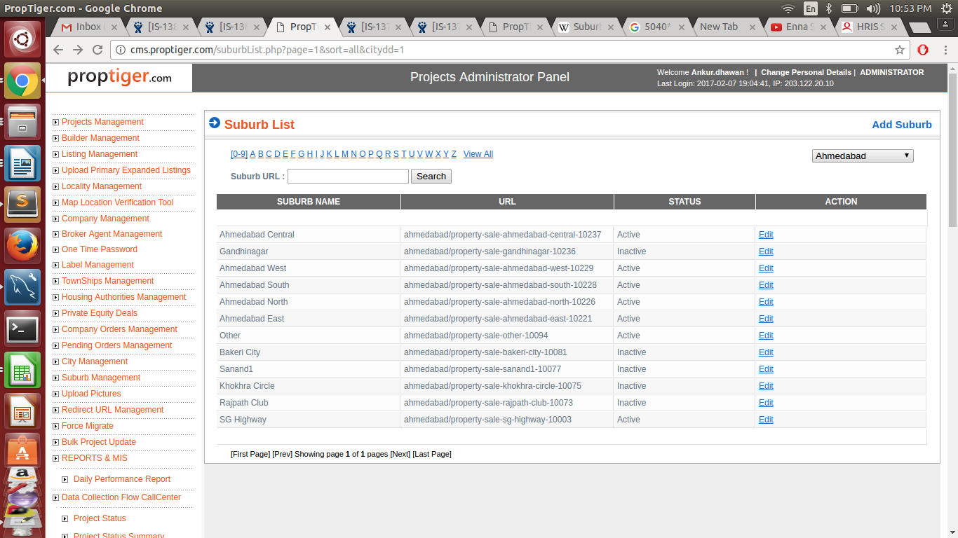

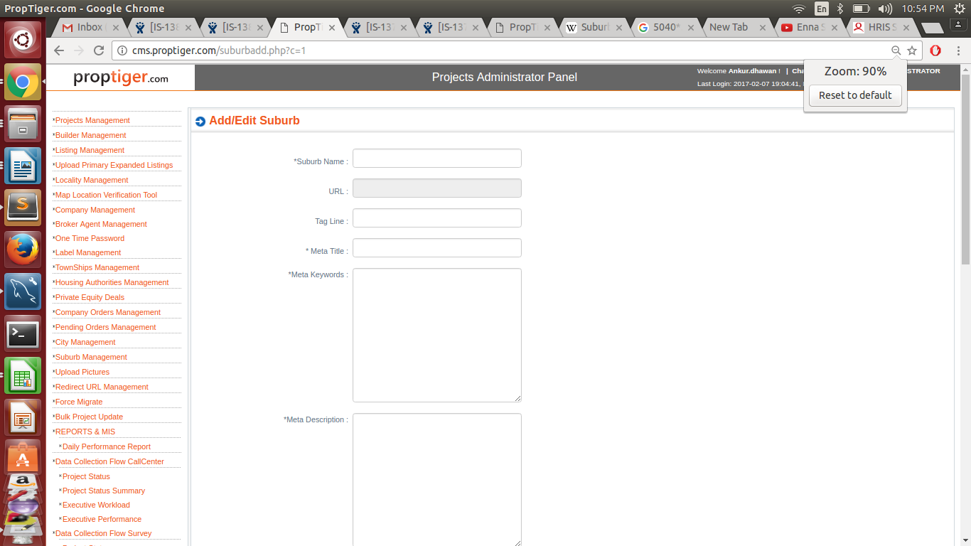

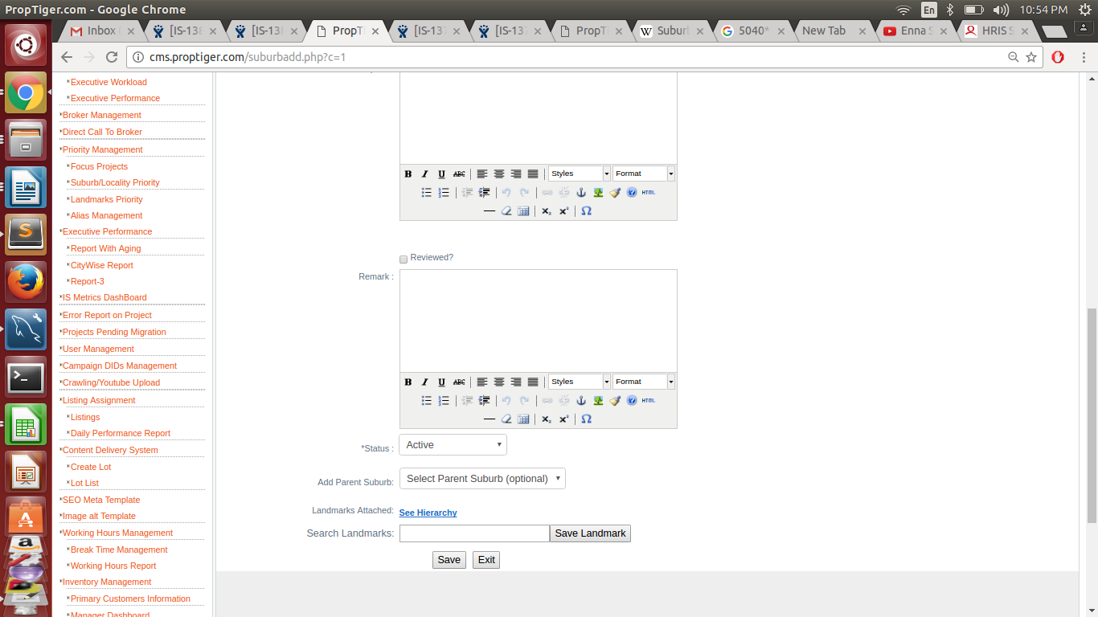

1.*suburb name
2.url
3.tag line
4.* meta title
5. *meta keywords
6.*meta description
7.description
8.reviewed
9.Remark
10.status.
11. add

